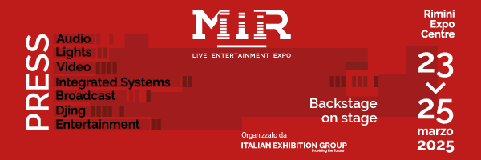

press release

IEG: MIR 2025 IS PUTTING TOGETHER A NEW EDITION
WITH EXTRA PAVILIONS, LIVE STAGES AND PROFESSIONAL TRAINING

- Organised by Italian Exhibition Group, the only B2B event in Italy dedicated to audio, video, lighting, sound, systems integration and broadcast technologies will return to Rimini Expo Centre from 23 to 25 March 2025;
- The 8th edition of MIR – Live Entertainment Expo will present an expanded exhibition area and experiential events;
- New format for training sessions, with masterclasses for audio and lighting technicians

Rimini, 2 July 2024 – MIR – Live Entertainment Expo, the Italian Exhibition Group's B2B event dedicated to integrated audio, video, lighting and sound, systems integration and broadcast solutions and the one-of-a-kind sector event in Italy, is already planning its return to Rimini Expo Centre from 23 to 25 March 2025, with an even bigger 8th edition and many new features in store.

In the wake of numbers from the 2024 edition - which recorded +20% visits and 20% growth in exhibitors – not to mention the public’s appreciation of the professional operators in over 50 hours of events and 4 immersive rooms, MIR is taking over more pavilions, offering an even more experiential programme, with live stages and several demo sessions.
MIR 2025 will hone in on the world of Live Production with a dedicated exhibit area and training sessions with leading industry experts: a key feature of next year’s edition will be professional training, with a new format dedicated to master classes for audio and lighting technicians, combined with panels, workshops and seminars.

MIR Club, the renowned space dedicated to the world of DJing and Club culture will merge the exhibit areas of the international players with live performances and new initiatives aimed at producers and the screenshot generation.

MIR Club aspires to be an incubator of ideas, unveiling the latest technologies in DJing and home studios, but above all acting as an important meeting ground for users, professionals, artists, protagonists and new media experts among the most influential on the Italian scene.

In the heart of a locality with a long-standing tradition and reputation for entertainment shows and live music, next year MIR will be looking to the future of the industry by multiplying business, experiential and networking opportunities for the professional live entertainment community.

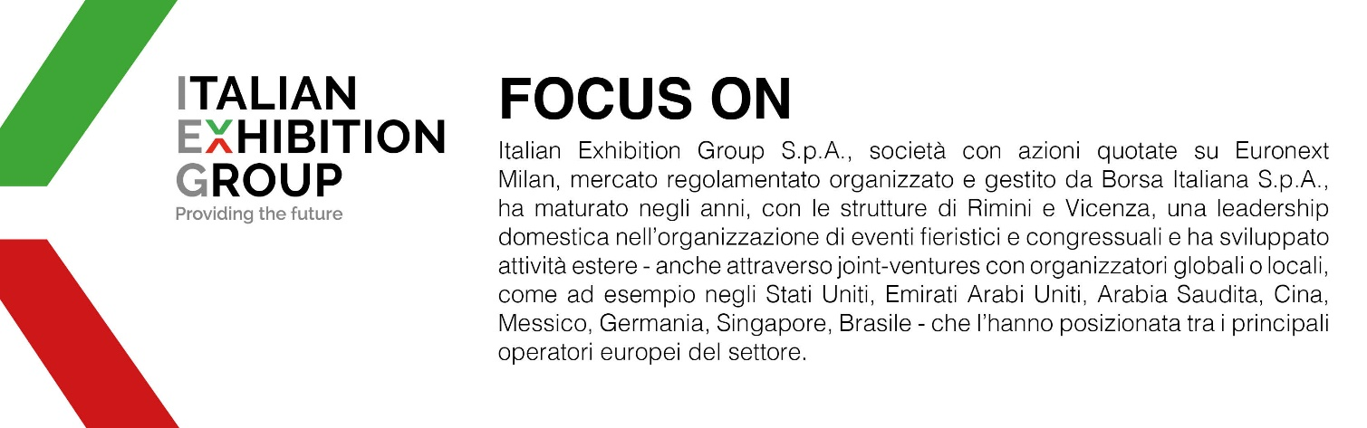

ABOUT MIR 2025
Organiser: Italian Exhibition Group S.p.A.; Recurrence: annual; Edition: 8th, from 23-25 March 2025; Open to: professional operators and general public; website: www.mirtechexpo.com

PRESS CONTACT ITALIAN EXHIBITION GROUP
head of media relation & corporate communication: Elisabetta Vitali; press office manager: Marco Forcellini, Pier Francesco Bellini; press office specialist: Luca Paganin, Mirko Malgieri

This press release contains forecast elements and estimates that reflect the management´s current opinions (´forward-looking statements´), particularly regarding future management performance, realization of investments, cash flow trends and the evolution of the financial structure. For their very nature, forward-looking statements have a component of risk and uncertainty, as they depend on the occurrence of future events. The effective results may differ (even significantly) from those announced, due to numerous factors, including, only by way of example: food service market and tourist flow trends in Italy, gold and jewellery market trends, green economy market trends; the evolution of raw material prices; general macroeconomic conditions; geopolitical factors and evolutions in the legislative framework. Moreover, the information contained in this release, does not claim to be complete, and has not been verified by independent third parties. Forecasts, estimates and objectives contained herein are based on the information available to the Company as at the date of this release.

